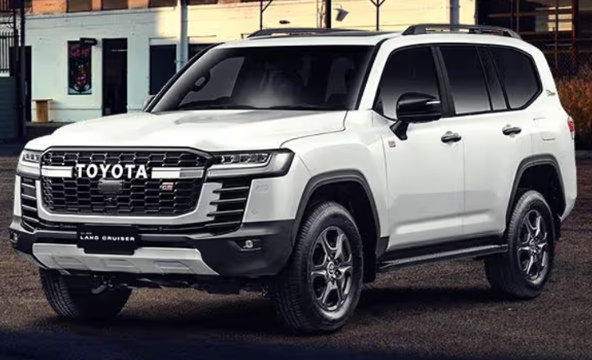

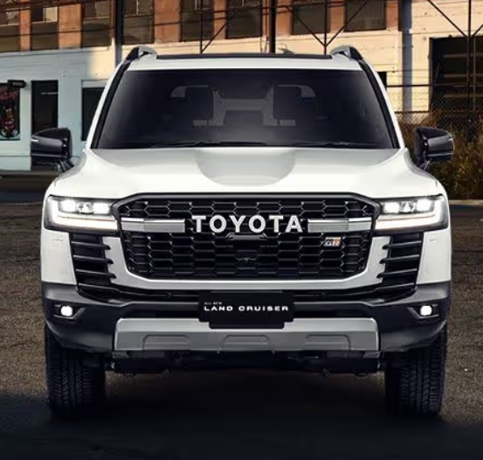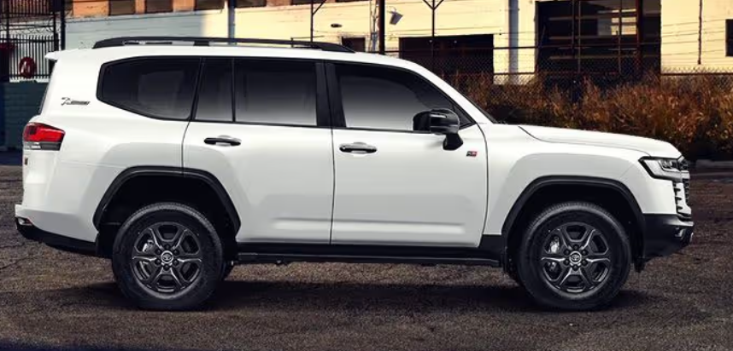

Main Specification of Toyota Land Cruiser

**🚗 Powertrain Options**

**Hybrid 2.4 L i‑FORCE MAX (Gas + Electric)**

* 2.4 L turbocharged inline‑4 with hybrid
* **Power**: 326 hp @ 6,000 rpm
* **Torque**: 465 lb‑ft (630 Nm) @ 1,700 rpm
* **Transmission**: 8‑speed automatic (ECT‑i)
* **Drivetrain**: Full‑time 4WD; locking center & rear diff
* **Fuel Economy**: ~23 mpg combined (EPA est); 22 city / 25 highway
* **Tank**: 17.9 gal (68 L
* **3.3 L Twin‑Turbo Diesel V6 *(Select markets)***
* 3.3 L twin‑turbo V6 diesel (F33A‑FTV)
* **Power**: 227 kW (~305 hp); **Torque**: 700 Nm (~516 lb‑ft)
* **Transmission**: 10‑speed automatic
* **Fuel Efficiency**: ~8.9 L/100 km (26 mpg); ~10–13 L/100 km observed
* **3.5 L Twin‑Turbo V6 Petrol (ZX variant)**
* 3.5 L V6 petrol twin‑turbo (V35A‑FTS)
* **Power**: 409 hp @ 5,200 rpm; **Torque**: 650 Nm @ 2,000–3,600 rpm
* **Transmission**: 10‑speed automatic

**📐 Dimensions & Capacities**

| **Spec** | **Metric / Imperial** |
| --- | --- |
| **Length** | ~4,985 mm / 193 in |
| **Width** | ~1,980 mm / 78 in |
| **Height** | ~1,920–1,935 mm / 75–76 in |
| **Wheelbase** | 2,850 mm / 112 in |
| **Ground Clearance** | ~245 mm / 9.7 in (air suspension option varies) |
| **Curb Weight** | Hybrid: ~5,038 lb / 2,285 kg; Diesel: ~2,495–2,630 kg |
| **Fuel Tank (Diesel/Hyb)** | 80 L (diesel), 68 L (hybrid) |
| **Seating Capacity** | 5 or 7 seats depending on trim |
| **Cargo Volume** | ~1,062 L behind rear seats (~37 cu ft) |

**🛠️ Performance & Off-Road**

* **0–62 mph**: Hybrid ~9.5 s; Diesel ~12.7–12.8 s
* **Max Speed**: Petrol ~109 mph; Diesel ~103–106 mph
* **Braked Towing**:
  + Hybrid/petrol: up to 6,000 lb (2,722 kg)
  + Diesel/petrol UK: 3,500 kg
* **Approach/Departure Angles**: ~31°/17°; Breakover ~25°
* **Suspension**: Double-wishbone front; multi-link rear; adaptive air option
* **Off-Road Features**: Crawl Control, Downhill Assist, Multi-Terrain Select, optional locking diffs and front stabilizer disconnect

**🛡️ Technology & Safety**

* **Drivetrain**: Full‑time 4WD with center & rear diff locks (hybrid/petrol); diesel AWDS
* **Brakes**: Ventilated discs all around, ABS & EBD, regenerative braking on hybrid
* **Steering**: Electric power rack & pinion; ~6.0 m turning radius
* **Safety & Driver Aids**:
  + Toyota Safety Sense 3.0 (DRCC, Pre-collision, Road Sign Assist, LTA)
  + Blind-spot, trailer merge warning, front/rear parking assist, 9 airbags, digital mirrors option

**✅ Summary**

The 2025 Land Cruiser offers a versatile line‑up:

* **Hybrid 2.4 L** for strong power (326 hp), torque, and 4WD capability—best combo of performance and efficiency.
* **3.3 L Diesel V6** for serious torque (700 Nm) and rugged utility in many markets.
* **3.5 L Petrol Twin-Turbo V6** (ZX) for peak power and refinement.